CMP NEWSLETTER 2019-20

KENDRIYA VIDYALAYA NO. 1 R.C.F. HUSSAINPUR

QUARTER-1(April to june)

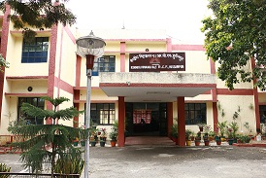
Kendriya Vidyalaya No-1 R.C.F- Hussainpur
HUSSAINPUR(KAPURTHALA)
PHONE NO 01822-228461 WEBSITE:- http://no1hussainpur.kvs.ac.in/
Every child is a different kind of flower.
All together they make this world a beautiful garden

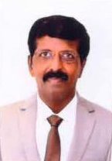

Editor CUM c.c.a Co-ordinator

MS. INDU SHARMA , PRT.
MS. RAJNI,PRT.

Special Thanks to all the students & the staff of PRIMARY SECTION OF K.V NO.1 R.C.F HUSSAINPUR
CHIEF PATRON

DR. P. DEVKUMAR
(DEPUTY COMMISSIONER, KVS, CHD. REGION)
OUR MENTOR AND GUIDE
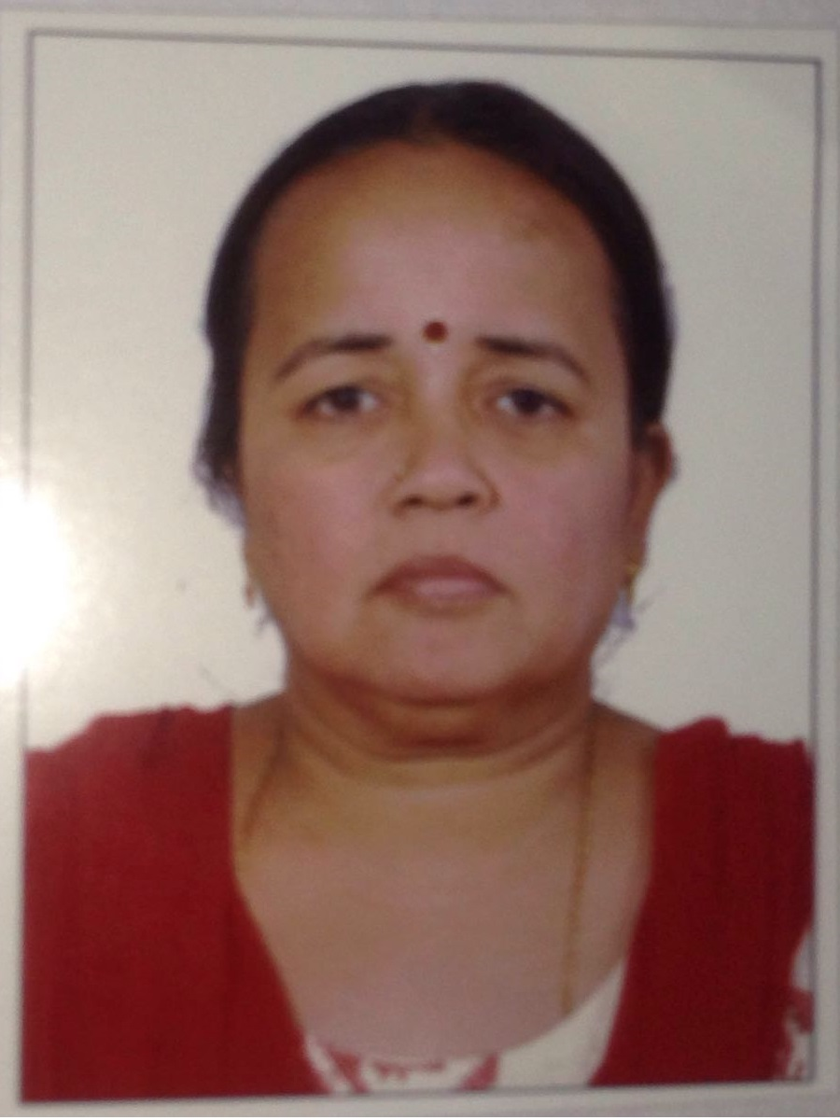
MS. T.RUKMANI
ASSISTANT COMMISSIONER,KVS CHANDIGARH REGION

PATRON
MRS. HARJEET KAUR
PRINCIPAL
Editorial Board
Chief EDITOR
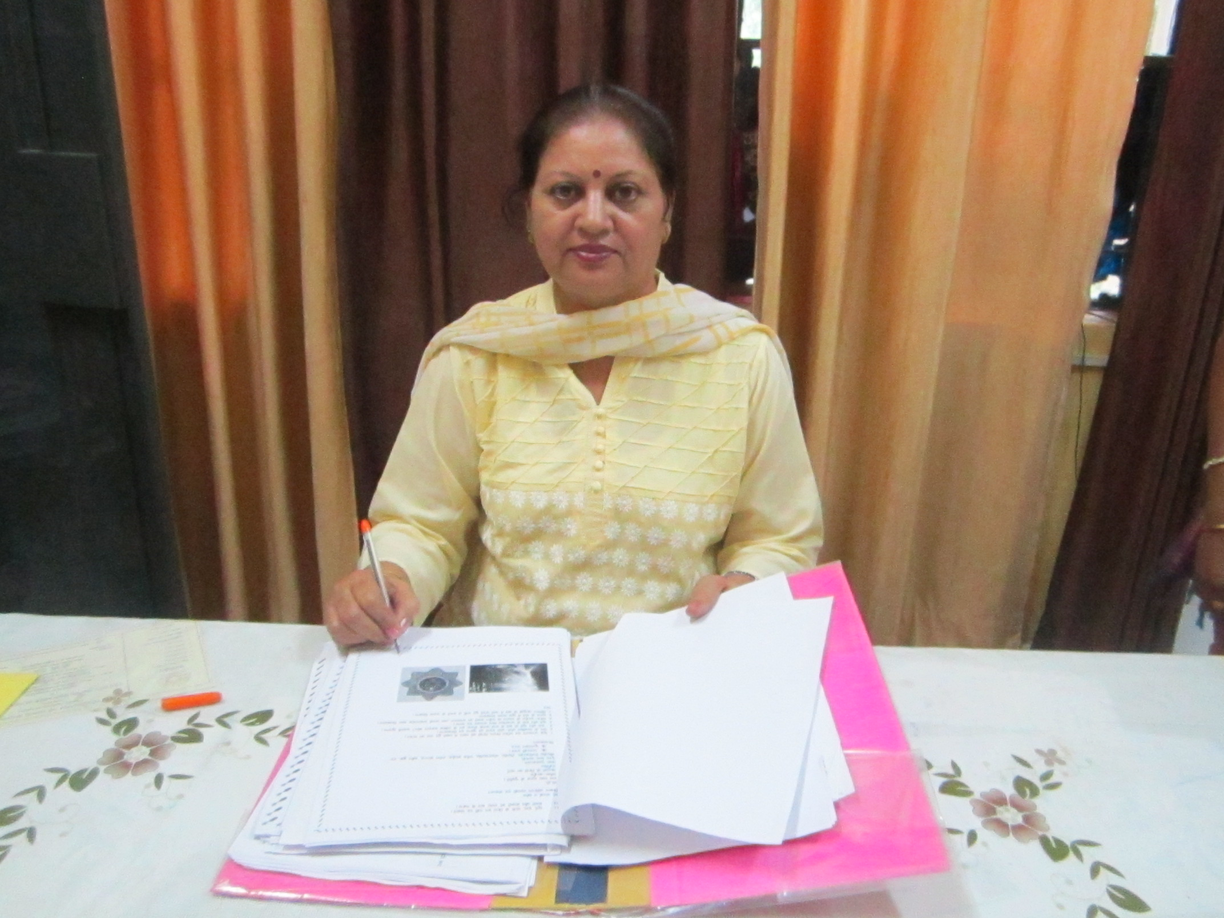
MRS. SUSHMA SHARMA, HM

:-

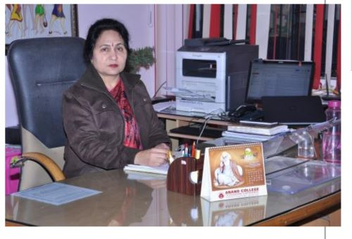

It gives me immense pleasure to share the glimpses of the activities of CMP for the Quarter 1 of Session 2019-20 i.e April to June 2019 of Kendriya Vidyalaya No.1 R.C.F Hussainpur. Common Minimum Program is an effective tool to facilitate teaching learning process in true spirit. The aim of education is overall development of the child, physical, mental as well as emotional. CMP does this job effectively. Our students learn as well as develop key life skills and are sensitive to the needs of the society. Our team at K.V.1 makes consistent efforts to make learning a joyful experience for our tiny tots.
Mrs. Harjeet Kaur,Principal

It gives me great pleasure to bring out the news letter that mirrors the primary children's activities under CMP during the Quarter 1 of Session 2019-20 i.e April to June 2019. At KV 1 RCF Hussainpur,we believe that every child has an innate ability to learn. Our team of dedicated teachers provide the students with a conducive learning environment and ample opportunities through which a child can realize his/her hidden potential. This CMP newsletter is reflection of activities organized in the school for harmonious development of the students. I also extend my sincere thanks to the Principal Mrs. Harjeet Kaur for her valuable guidance and inspiration.
Sushma Sharma,Offg. HDM

GLIMPSES OF THE ACTIVITIES AT KV NO.1 RCF HUSSAINPUR
ANNUAL FUNCTION 2018-19
Annual function was organized in our school campus with great enthusiasm on 8th of May,2019. Our chief guest Mr. …………….,PCME ,RCF Hussainpur inaugurated the function with lighting of lamp. Function concluded with prize distribution for the session 2018-19.
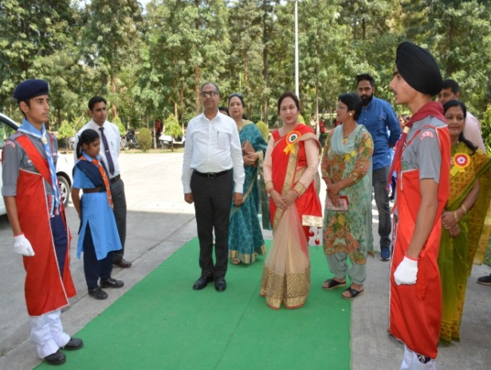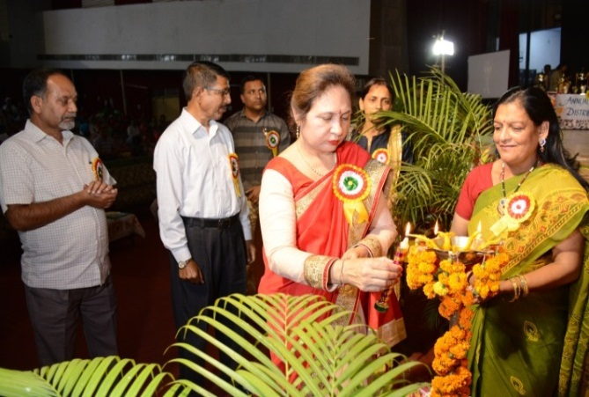
Welcoming of Chief Guest Lighting of Lamp by our worthy Principal
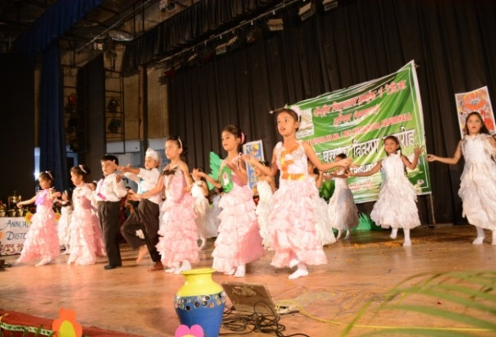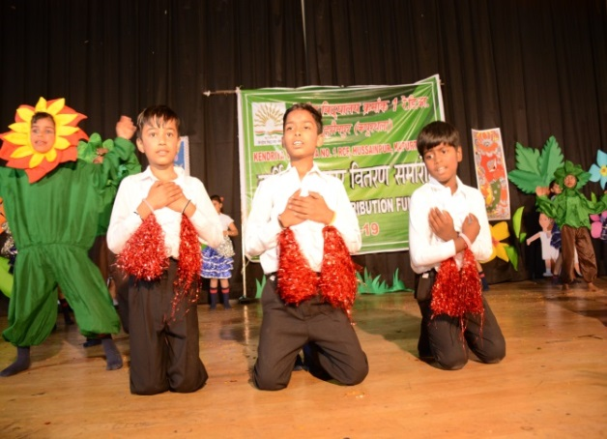
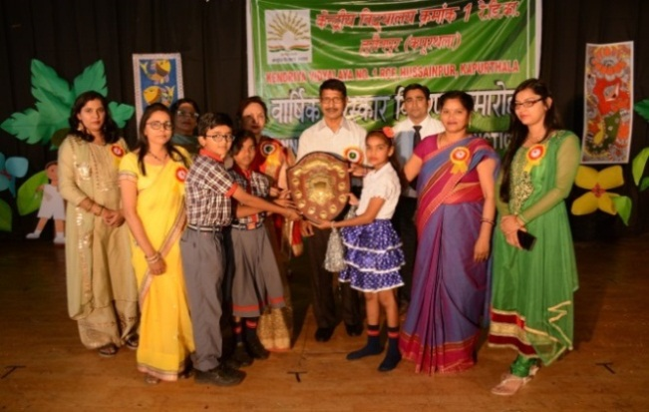
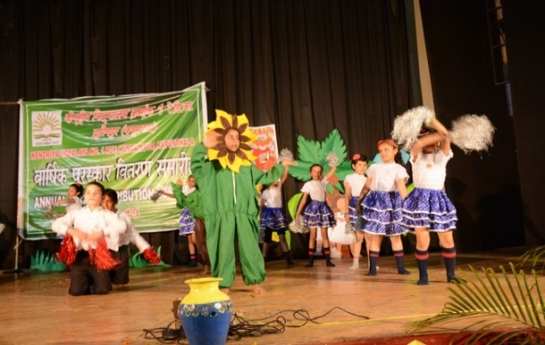
Welcome Dance by primary Students

Group Dance(Theme-Go green) by primary Students Overall winner of CCA Activities
The future belongs to those, who believe in the beauty of their dreams.
INTERNATIONAL YOGA DAY
International Yoga day was celebrated on 21st of June,2019 by the students and teachers at K.V. No. 1 R.C.F. Hussainpur with great enthusiasm. Students of primary section demonstrated various Asanas as instructed by Ms. Preeti Saini.
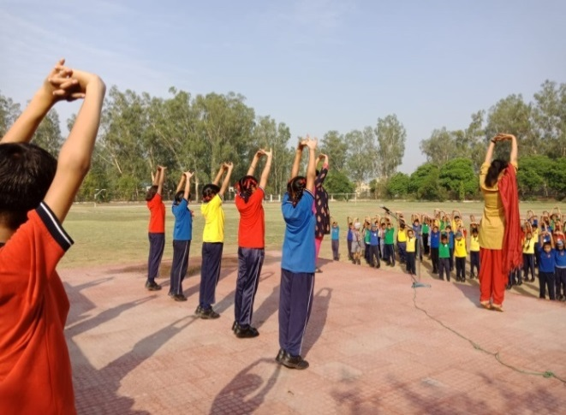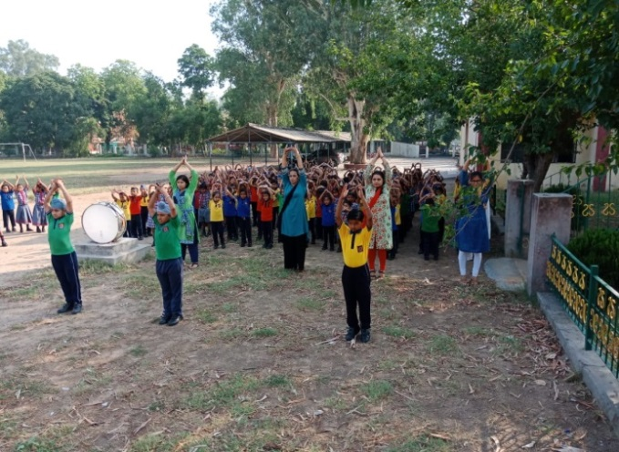
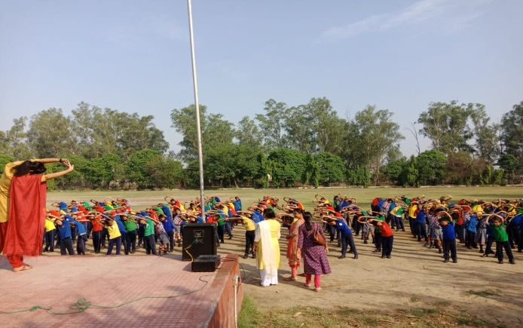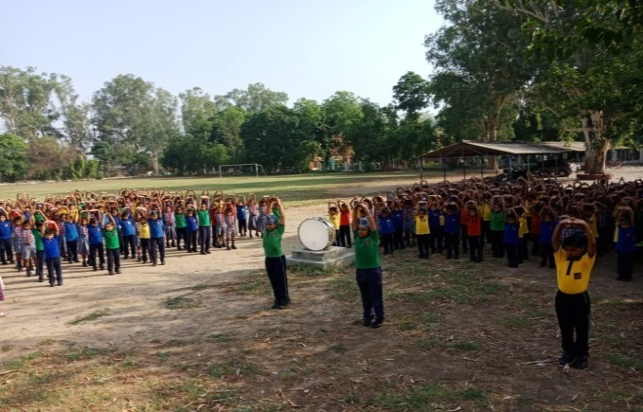
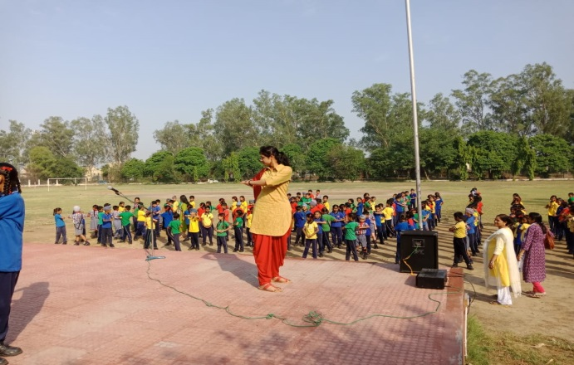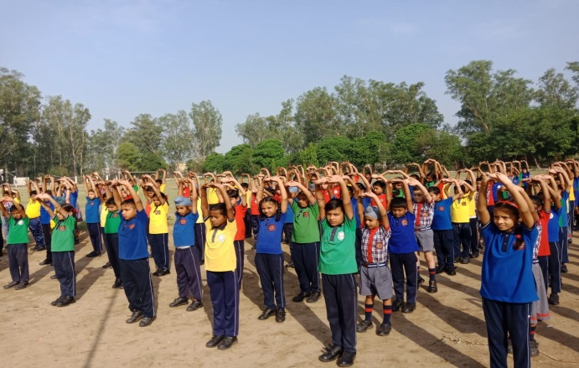
Yoga is the art work of awareness on the canvas of body, mind and soul.

C.C.A ACTIVITIES / COMPETITIONS
Co-curricular activities are important part and parcel of educational institutions to develop students’ personality as well as to strengthen class room learning.
DRAWING & PAINTING COMPETITION
K.V. NO.-1 RCF Hussainpur organized Drawing and Painting competition on 27th April 2019. The topics were ‘Save Enviornment’ , ‘Save Earth’ and ‘Save Water’. Students enthusiastically took part in the competition and made many wonderful paintings on the given topics.
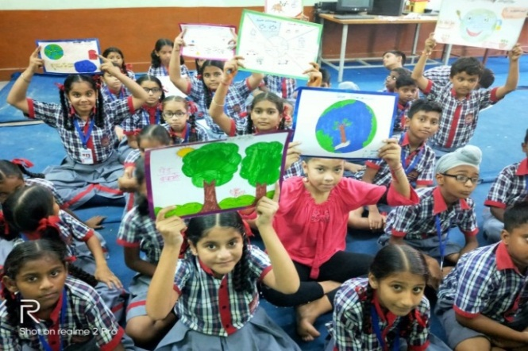
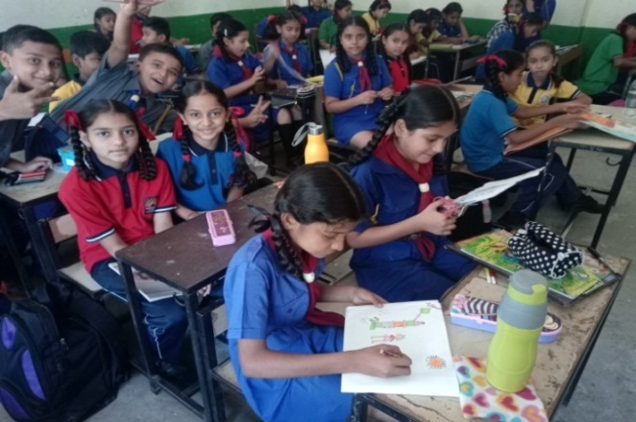

SLOGAN WRITING COMPETITION
K.V. NO.-1 RCF Hussainpur school organized a slogan writing competition at Primary level for class III to V on 22nd of June, 2019. Theme was based on ‘International Yoga Day’ in which students took part with great enthusiasm and wrote relevant slogans based on the importance of yoga.
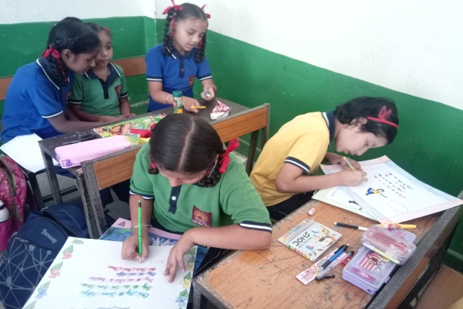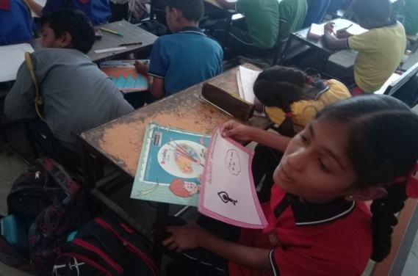
“Colour in a painting is like enthusiasm in life”

INTER-HOUSE DISLAY BOARD DECORATION COMPETITION
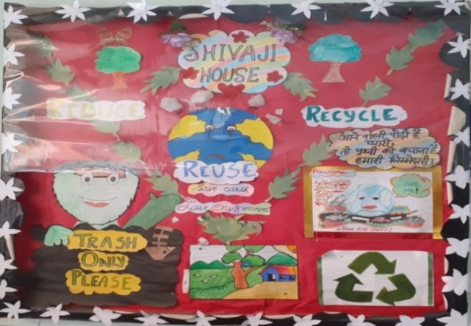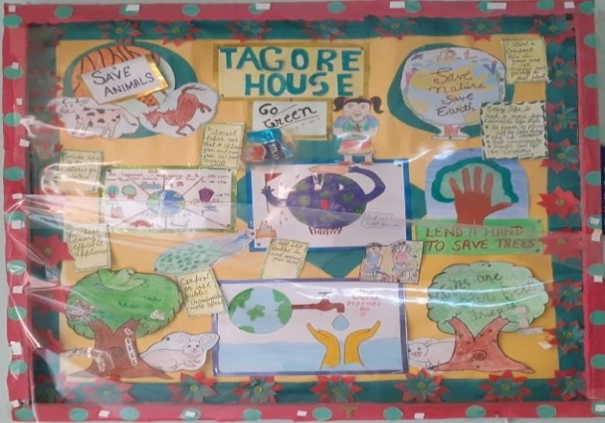
Shivaji House Tagore House
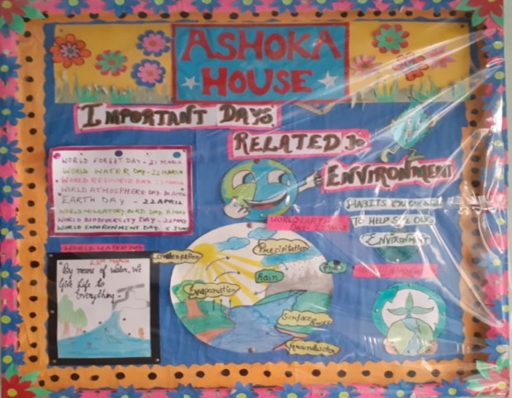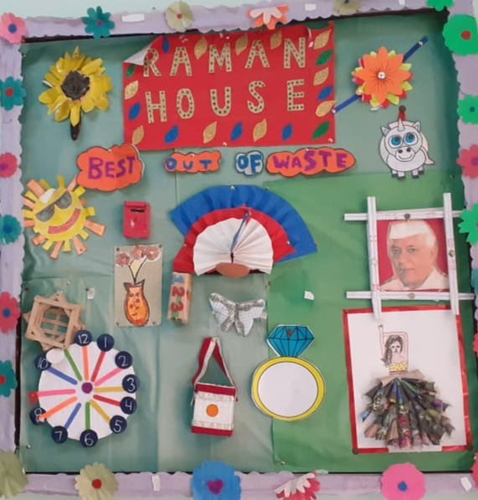
Ashoka House Raman House
CLASS 1 ORIENTATION & SCHOOL READINESS PROGRAMME
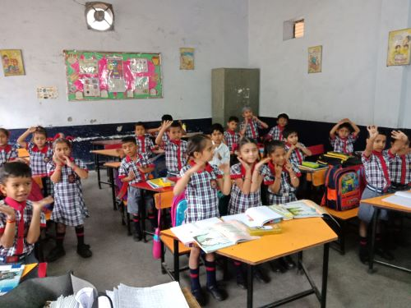
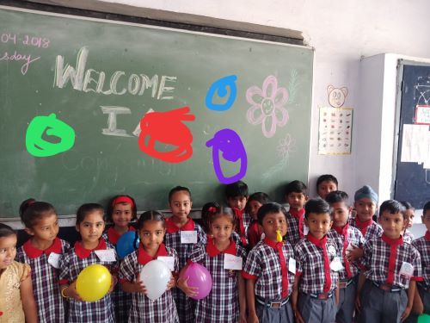

There is no elevator to success. You have to take the stairs.
Activities carried out by class I students under school readiness programme
FUNDAY ACTIVITIES
To Bring out the hidden talent in different fields and promote all round development of the students. Following Activities like Origami, Drawing & Painting, Rakhi Making, Dramatization, File Decoration, Best out of waste etc. are being conducted in the Vidyalaya.
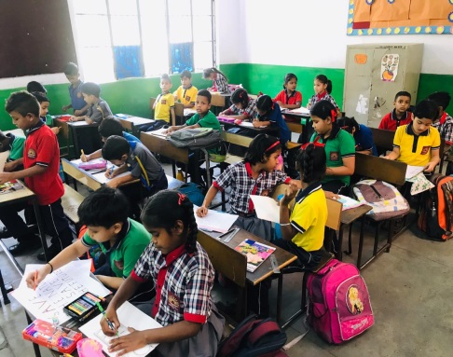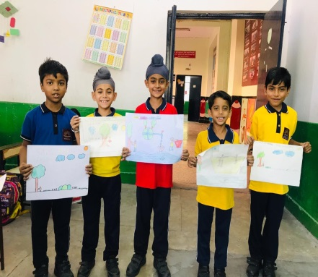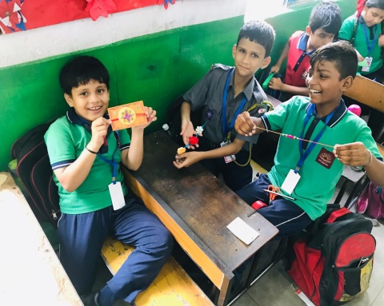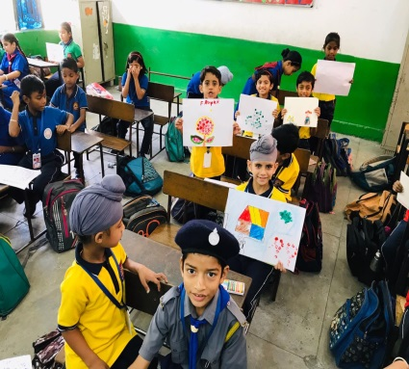
It is the supreme art of the teacher to awaken joy in
creative expression and knowledge.

“Every Child is born creative. The challenge is to keep that CREATIVITY ALIVE.”

